Appendix B – Tropical Weather Plan

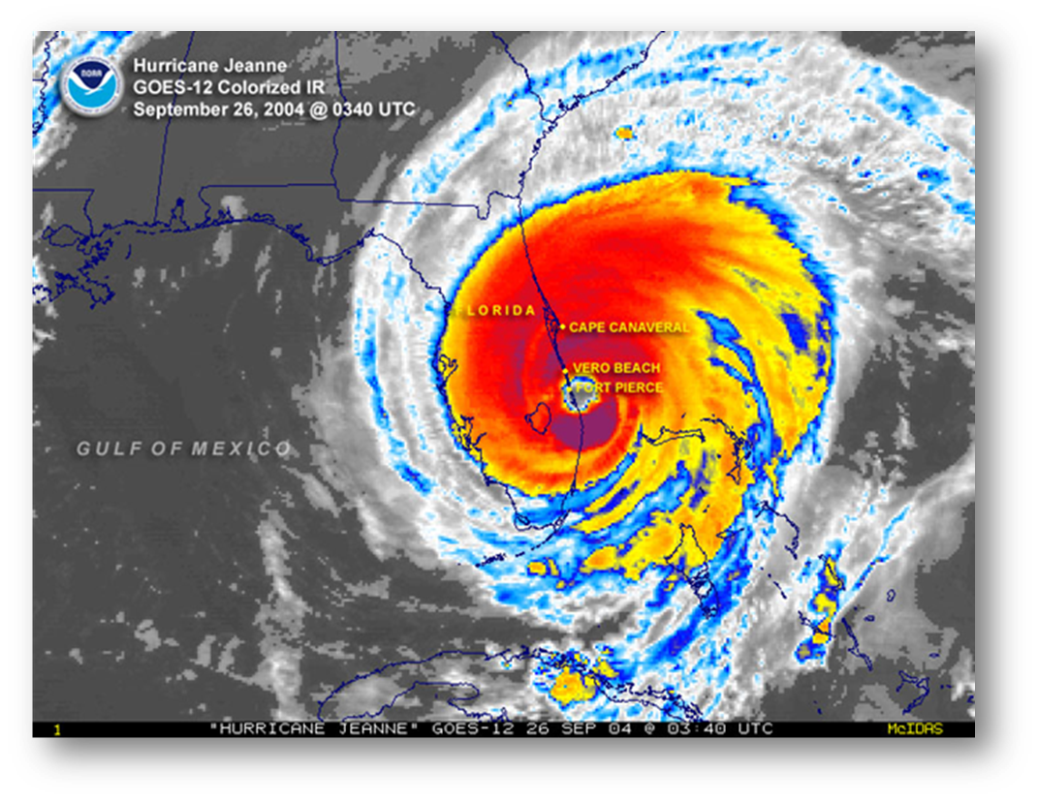
- Introduction and Purpose
- The University of Florida (UF) Campus is vulnerable to impacts from tropical storms and hurricanes. The objective of the appendix is to establish procedures to protect students, staff and faculty, minimize storm-related damage to UF property and facilitate recovery including adequate documentation for insurance and FEMA reimbursement.
- It is important for all UF units to be prepared for the impacts of tropical weather. This plan serves as a tool to assist departments in responding to and recovering from potential and actual impacts.
- Situation and Assumptions
- Tropical weather will impact UF requiring units to take protective actions, and forecasts will provide advance notice of potential tropical weather.
- Primary concern will be life-safety issues followed by protection of UF property and environment.
- Each department is responsible for executing their own preparedness and recovery actions including monitoring information provided by the University.
- This plan may be activated for extratropical storms and other high-wind events if adequate warning time is available.
- Concept of Operations
- Weather Monitoring
  - Hurricane Season occurs June 1st through November 30th of each year. Departments will monitor the weather throughout hurricane season for the possibility of any local impacts.
  - Tropical weather information is available from numerous sources ranging from local media to the internet weather sources. Below are suggested websites to monitor during hurricane season:
Tropical Weather Websites
- National Hurricane Center:
  - http://www.hurricanes.gov
- NWS-Jacksonville:
  - https://www.weather.gov/jax
- UF Emergency Management Hurricane Tracking:
  - https://emergency.ufl.edu/emergency-information/hurricane-tracking/
- Weather Statements
  - For decision-making purposes, UF will follow the official advisories and forecasts issued by the National Hurricane Center and the National Weather Service-Jacksonville. (Reference websites in Section III.A.2 above)
  - Tropical depression, tropical storm and hurricane forecasts are issued by the National Hurricane Center every six hours for an active storm. Normally, forecasts are available at 5am, 11am, 5pm and 11pm EDT (or 4am, 10am 4pm and 10pm EST). The forecast packages project the path and intensity of the storm for a five-day period. If required, watches and warnings for coastal areas only are included in the forecasts. Intermediate public advisories may be issued every three hours when coastal watches or warning are in effect, and every two hours when coastal watches or warnings are in effect and land-based radars have identified a reliable storm center.
Tropical Cyclone Classifications
- Tropical Depression – 38mph or less sustained wind speed
- Tropical Storm – 39mph to 73mph sustained wind speed
- Hurricane – 74pmh or greater sustained wind speed
  - Local weather watches and warnings covering the UF Campus are issued by the National Weather Service-Jacksonville. The forecast office will generate Tropical Storm and Hurricane watches and warnings advisories if Alachua County is forecast to be impacted. Additionally, a Hurricane Local Statement will be issued at least every six hours when a tropical storm or hurricane watch or warning is in effect for the NWS-Jacksonville County Warning Area.
- Protective Action Decisions
  - When tropical weather threatens the area, it may be necessary for UF to suspend some or all operations in order to protect lives and property. Closure decisions will be made according to the UF Comprehensive Emergency Management Plan.
  - Units will monitor information provided by the University regarding potential or actual closures and be prepared to suspend departmental operations. Some departments will be required to continue certain essential functions.
  - The official source for UF emergency information is the University’s home page – www.ufl.edu. Closure and opening information along with other important statements will be posted on the website and sent through various UF Alert methods. Information will also be provided to the local media regarding UF’s status.
  - Off-site facilities, outside of Alachua County, will follow information provided by their department/division regarding operational status. Normally, off-site facilities will head the closure schedule of local governments where the facility is located.
- Assignment of Responsibilities
- Pre-Storm
  - Units will review their Departmental Tropical Weather Response and Recovery plan along with any related department specific emergency plans.
  - Any specific assignments should be outlined by position.
  - Departments will alert personnel with essential functions and specific roles to ensure their ability to fulfill obligations.
  - Departments will make necessary preparations for the possibility of UF suspending normal operations.
  - Departments will fuel state vehicles. (During hurricane season, it is recommended departments maintain as a minimum half-full tanks in vehicles during normal conditions.)
- UF Suspension of Normal Operations (Closure)
  - Units will complete the appropriate checklist for securing administrative/office areas and/or laboratory/research areas. (Checklists are included as Attachments A and B of this document)
  - Units will complete a general survey around each building and rooftop where accessible. Loose items should be brought inside or secured. Departments in shared facilities should coordinate actions.
  - Units should follow guidance from their IT provider regarding computer and data systems including back-up and storage of data.
  - Units will park fueled vehicles in a secure location. Interior sections of parking garages or in parking lots away from trees are appropriate locations. Normally, this task should be completed by the vehicle’s primary user. Vehicle actions should be logged on Attachment C of this document and posted in the department/unit area.
- During Storm
  - During a storm, when UF normal operations are suspended, only those performing essential functions, on-campus residents or those in UF shelters should be on Campus. During periods of high winds everyone should shelter in secure locations and not travel.
  - Faculty, staff, students and their families may choose to stay in hurricane shelters open at UF. (University Housing residents should follow the instructions of UF Department of Housing and Residence Education regarding sheltering procedures.)
  - Units with employees conducting essential functions during the storm will complete the contact information form and email to the University of Florida Police Department (UFPD). (Form is included as Attachment D of this document.)
Note: If departmental staff must remain on Campus to maintain essential functions, additional planning beyond the scope of this template is required for the department. Plans should address the needs of the critical operations and employees. Employee safety during an event is paramount.
- Post-Storm
  - If needed, follow damage assessment process outlined in section III.C.1 of the [insert department] Emergency Plan.
  - Take safe, protective actions that mitigate or reduce hazards in buildings and areas. (Example - placing barricade tape around a dangerous area in a building to prevent people from entering the area.) Faculty and staff should not take any actions which place themselves or others in danger.
  - Monitor and follow guidance from the University and local officials regarding any special policies and procedures that may be in place following a storm.
  - At the work unit level, account for the well-being of all faculty and staff once UF has resumed normal operations.
  - If a department is unable to fulfill its functions as a result of damaged facilities or equipment, the department may need to activate its Continuity of Operations (COOP) plan. (Reference Appendix C)
- Logistics
The materials listed below are contained as attachments to this document and are intended to aid in its execution.
- Laboratory and Research Areas Checklist – Document outlines tasks that should be completed as appropriate when UF suspends operations due to tropical weather. (Reference Attachment A)
- Administrative and Office Areas Checklist – Document outlines tasks that should be completed as appropriate when UF suspends operations due to tropical weather. (Reference Attachment B)
- Tropical Weather Vehicle Assignments – Form for logging where vehicles have been parked and key located in preparation for tropical weather. (Reference Attachment C)
- Essential Contacts during Suspended Operations - Document should be completed and emailed to UFPD if employees remain on Campus during tropical weather when UF has suspended operations. (Reference Attachment D)
- Initial Damage Assessment Form – Form should be completed if building was damaged during a storm event. (Reference Attachment E)
- Information Posting – Form should be completed and posted in departmental work area for each building. (Reference Attachment F)

