Attachments

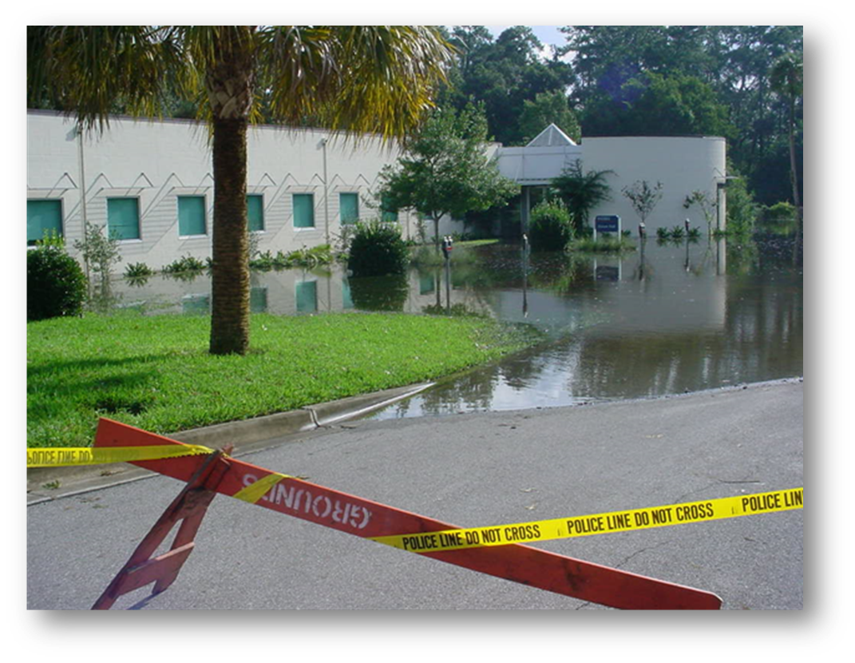

Attachment A – Laboratory and Research Areas Closure Checklist: Preparations for Tropical Weather/Hurricanes
Departments are responsible for taking protective actions in their own laboratories. This checklist is designed to identify suggested tasks and assignment of responsibilities for preparing laboratory areas. Not all items are appropriate for all areas. Departments and researchers should add actions specific to their individual laboratories if needed. The checklist should be completed as a part of Appendix B – Tropical Weather Plan.

When impacts from tropical weather are possible, consider necessary preparations to suspend ongoing experiments involving biological materials, radioactive agents and hazardous chemicals. When UF suspends normal operations, postpone operations in the laboratory, secure equipment and complete the checklist. Note, personnel should not stay in the laboratory during a storm if UF has suspended normal operations.

Additional mitigation steps can be taken year-round to reduce impacts from tropical weather and other incidents, including:

- Keep chemical, radiological and biohazardous materials in your inventory to a minimum.
- Dispose of hazardous wastes and old chemicals routinely to minimize accumulation of hazardous materials in your facility.
- Laboratories with exterior windows should identify a secure area for storage of water reactive chemicals, radioactive materials and biohazardous agents. Ideally, materials with significant, potential hazard should be moved to interior rooms. (e.g. – solvents containing reactive metals, glove boxes containing air reactives)
- If dry ice will be needed pre- or post-incident, document vendor information, payment method and delivery or pick-up options. Note, dry-ice should not be transported in a closed vehicle for safety of the occupants.
- Maintain a supply of plastic, waterproof containers to store reactive chemicals, lab notes, research documentation, electronic data and other important materials.
- Plan in advance how to ensure the protection of valuable research equipment, samples and data.
- Contact appropriate work management center (PPD, IFAS Facilities) if planning to use portable generator to determine appropriate and safe use, connection and fueling. Note, portable generators are normally not provided by work management centers.
- Maintain a stock of critical supplies to prevent disruptions.
- Update and distribute emergency and contact information to laboratory personnel. Regularly maintain emergency call list on the notice board at the laboratory door.

 | Action/Task | Location | Staff Responsible |  | Notes
 |  |  | Primary | Alternate
 | Turn down refrigerators and freezers to the lowest practical settings and plug into emergency power where available. Red outlets typically designate emergency power.
 | Place recording maximum/minimum thermometers in refrigerators and freezers containing temperature critical supplies and samples.
 | Plug incubators into emergency power outlets if you must maintain cultures in vitro.
 | Cover and secure or seal vulnerable equipment with plastic.
 | Remove or secure equipment from outdoor and rooftop locations.
 | Ensure arrangements have been made for the care and feeding of laboratory animals. Follow recommended actions of UF Animal Care Services.
 | In areas subject to flooding, relocate or elevate equipment, chemicals, wastes and other important items from the floor to prevent damage.
 | Secure radioactive isotopes, biohazardous agents, recombinant materials and hazardous chemicals to prevent breakage and release.
 | Fill dewars and cryogen reservoirs for sample storage and/or critical equipment.
 | Over-pack reactive chemicals in plastic, waterproof containers.
 | Remove regulators and cap gas cylinders, except for CO2 needed to maintain cell cultures. Ensure all cylinders are secure.
 | Autoclave or inactivate infectious or rDNA waste.
 | Due to the possibility of power outages, store volatile, toxic materials in tightly sealed, break-resistant containers rather than fume hoods or open room.
 | Protect valuable files, research samples and notebooks in place or move to a safer location.
 | Protect notebooks and secure samples/data as necessary for colleagues unable to reach the lab.
 | Update emergency contact information including notification list on lab door. Add and expand temporary contact information if staying at a different location during storm.
 | Close and latch (or secure with tape if needed) filing cabinets and cupboards.
 | Back-up electronic data and store in multiple locations.
 | Follow IT provider instructions for computer equipment preparations.
 | Close and lock all doors and windows before leaving.
 | If appropriate, complete Attachment C – Vehicle Assignments for Tropical Weather.
 | If appropriate, complete Attachment B – Office and Administrative Areas Checklist.

Attachment B – Administrative and Office Areas Closure Checklist: Preparations for Tropical Weather/Hurricanes
Departments are responsible for taking protective actions in their own office and administrative areas. This checklist is designed to identify suggested tasks and assignment of responsibilities for preparing work areas. Not all items are appropriate for all areas. Departments should add actions specific to their individual work areas if needed. The checklist should be completed as part of Appendix B- Tropical Weather Plan.

When impacts from tropical weather are possible, consider necessary preparations to protect equipment, records and data. When UF suspends normal operations, prepare to close office and administrative areas and complete the checklist. Note, personnel should not stay in work areas, unless involved with essential operations, during a storm if UF has suspended normal operations.

Additional mitigation steps can be taken year-round to reduce impacts from tropical weather and other incidents, including:

- Plan in advance how to ensure the protection of files, records and valuable equipment.
- Obtain and store needed supplies, such as plastic sheeting to cover equipment and files.
- Discuss preparatory actions with personnel and assign responsibilities.
- Update and distribute emergency and contact information to personnel.

 | Action/Task | Location | Staff Responsible |  | Notes
 |  |  | Primary | Alternate
 | Cover and secure vulnerable equipment with plastic.
 | When possible, move equipment and other valuable items into interior areas of the building away from windows. Tag moved equipment with department contact information for easy identification and retrieval.
 | In areas subject to flooding, relocate equipment and other valuable items to a higher floor or elevate. Tag moved equipment with department contact information for easy identification and retrieval.
 | Remove or secure equipment from outdoor and rooftop locations.
 | Clear refrigerators and freezers of items that could spoil if power is lost, but leave appliance plugged in.
 | Place important records and files in cabinets and cover with plastic.
 | Close and latch (or secure with tape if needed) filling cabinets and cupboards.
 | Back-up electronic data and store in multiple locations.
 | Follow IT provider instructions for computer equipment preparations.
 | Clear desktops, tables and exposed horizontal surfaces of materials subject to damage.
 | Place telephone in desk drawer if the cord is long enough. Do not unplug telephones.
 | Take personal possessions home. UF is not responsible for personal items damaged.
 | Secure windows and close blinds.
 | Change voice mail to indicate UF closure. |  | All
 | Close and lock all doors, including office doors, before leaving.
 | If appropriate, complete Attachment C – Vehicle Assignments for Tropical Weather
 | If appropriate, complete Attachment A – Laboratory and Research Areas Checklist

Attachment C – Tropical Weather Vehicle Assignments
When completed copy, distribute and store in a known location
Reference Appendix B (Tropical Weather Plan), Section IV.B.4 - Departments will park fueled vehicles in a secure location. Interior sections of parking garages or in parking lots away from trees are appropriate locations. Normally, this task should be completed by the vehicle’s primary user.

 | Vehicle # | Vehicle Parking Location | Vehicle Key Location | Responsible Person

Attachment D – Essential Contacts During Suspended Operations
Complete for personnel staying on Campus during suspended operations and email this form / information to University Police Department at UPDDispatch@admin.ufl.edu.

Reference Appendix B (Tropical Weather Plan) - Departments with employees conducting essential functions during the storm will complete the contact information form and email to the University of Florida Police Department (UFPD).

Date_____________________________
Sent by___________________________
Department________________________

Building # / Name | Contact Name/  UFID | Phone Number(s) during event | Required Activity

Attachment E – Initial Damage Assessment Form
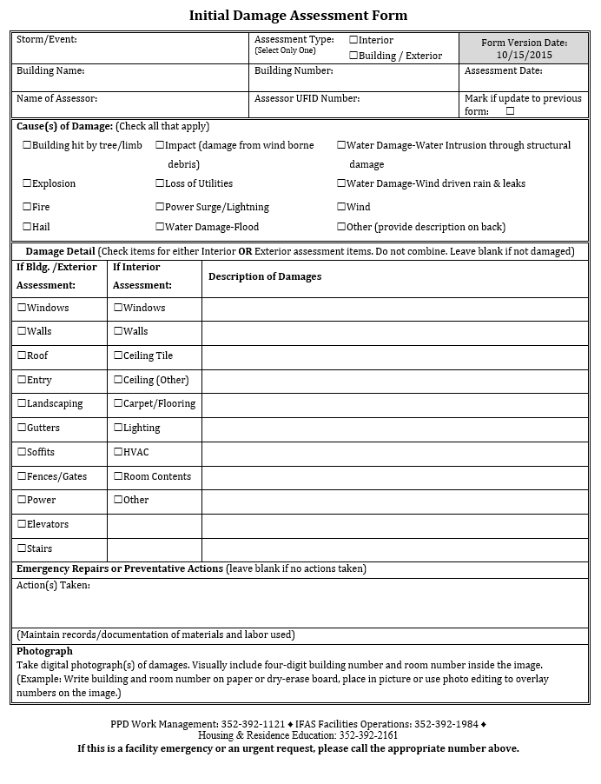

Attachment F – Information Posting
Please complete and display information (or equivalent) where notices are posted in your area
UF Building Name: ____________________________ Street Address: ____________________________________
UF Building Number: ______________________________________________________________________________
Building Emergency Coordinator (BEC) for ____ [insert department] ________________ in this building:
 | Primary | Alternate
Name
Work Telephone
Email
Office Location
Other

Emergency Telephone Numbers
Department | Normal Business Hours | Evenings/Weekends
Fire/Police/Medical | 911 | 911
University Police Department | 352-392-1111 | 352-392-1111
Environmental Health & Safety | 352-392-1591 | 352-392-1111
Pest Control (UF) | 352-392-3410/392-1591 | 352-392-1111
Biological Spill (UF) | 352-392-1591 | 352-392-1111
Chemical Spill (UF) | 352-392-8400/392-1591 | 352-392-1111
Radiation Spill (UF) | 352-392-7359/392-1591 | 352-392-1111
Needlestick-BioPath Hotline | 866-477-6824 | 866-477-6824
UF Workers’ Compensation | 352-392-4940
Florida Poison Information Center | 800-222-1222 | 800-222-1222

Work Management Centers
Physical Plant Department Work Management | 352-392-1121
IFAS Facilities Operation | 352-392-1984
Housing & Residence Education | 352-392-2161

[If off campus, insert building management contact information]

Attachment G – Acronyms
AAALAC: Association for Assessment and Accreditation of Laboratory Animal Care International
CEMP: Comprehensive Emergency Management Plan
CSHEMA: Campus Safety and Environmental Health Association
COOP: Continuity of Operations
EOC: Emergency Operations Center
ICS: Incident Command System
IT: Information Technology
NIMS: National Incident Management System
TBD: To be developed
UF: University of Florida
UPD: University Police Department
{Review and add others as needed}

Attachment H – Definitions
Continuity of Operations (COOP): Maintaining or resuming department critical operations despite a disruption or emergency.
Comprehensive Emergency Management Plan (CEMP). The CEMP is intended to establish policies, procedures, and an organizational structure for the response to emergencies that are of sufficient magnitude to cause a significant disruption of the functioning of all or portions of the University.
Emergency Operations Center (EOC). The EOC serves as the centralized, well-supported location in which the Emergency Operations Team and the Executive Management Team may gather and assume their respective roles.
National Incident Management System (NIMS). NIMS is a modular emergency management system designed for all hazards and levels of emergency response. The system is used by the Department of Homeland Security and throughout the United States as the basis for emergency response management.
[Insert other definitions specific to the Department as appropriate]

Attachment I – Resource List
- University of Florida Comprehensive Emergency Management Plan

- https://emergency.ufl.edu/emergency-management-plans

- University of Florida Safety Programs and Policies:

- Emergency Evacuation Procedures for People with Disabilities: www.ehs.ufl.edu/programs/ada/emergency/
- Community Awareness Brochures from the University Police Department: www.police.ufl.edu/community-services/community-awareness-brochures/

- Emergency Management Resources

- University of Florida Emergency Management: https://emergency.ufl.edu/
- Alachua County Division of Emergency Management: www.alachuacounty.us/Depts/PublicSafety/em/Pages/EmergencyManagement.aspx
- Florida Division of Emergency Management: https://www.floridadisaster.org/
- National Incident Management System (NIMS): https://www.fema.gov/national-incident-management-system

[Insert additional resources for the department that may be helpful to reference in this Plan]

Attachment J – Employees with Emergency Roles
Name | Title (Emergency Role) | Email Address | Work # | Home # | Cell # | Other #

Attachment K – Vendors and Partners
In the event of an emergency, the [insert department] will reference the following tables to determine appropriate stakeholders to contact regarding the emergency, including vendors that may provide resources to the Department during an emergency:

Vendor/Supplier | Service Provided | Emergency Contact | Alternate Source | Notes

Grant Funding Organizations | Associated Projects | Emergency Contact | Notes

Partners | Associated Projects | Emergency Contact | Notes

