Appendix C – Department COOP Plan

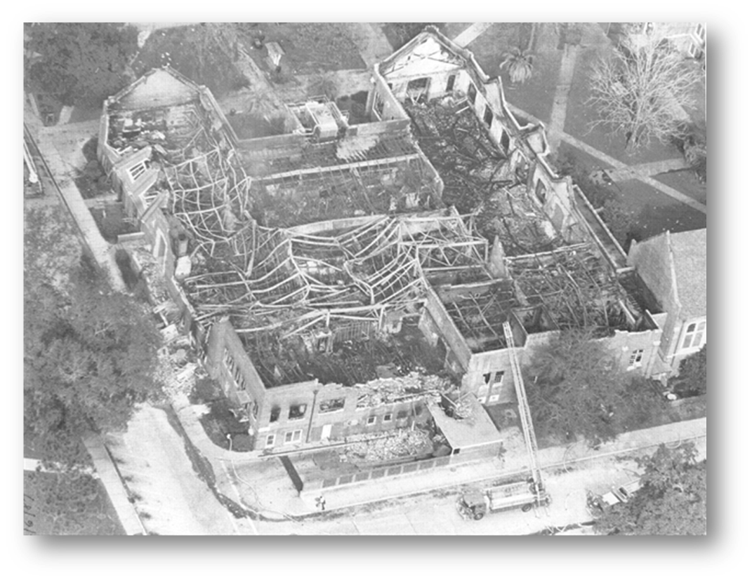
I. Introduction
A. Department COOP Objective

COOP (Continuity of Operations) is an effort within individual University of Florida units to facilitate the continued provision or restoration of mission essential functions during a wide range of potential emergencies.

B. Purpose and Scope

This document is intended to assist and guide preparation for and response to a COOP activation. The Annex outlines the essential functions, positions, equipment, records and other resources needed to implement this plan. Organization, relocation, delegation authority, and operation during a COOP activation are also described.

The COOP plan provides a framework for sustaining essential operations for up to 30 days. During this period, it is expected [Department] will coordinate with University administration to determine long-term arrangements necessary to restore complete operations.

C. Situation and Assumptions

- Emergencies can cause disruptions to operations, damage to facilities and impact employees.
- Emergencies, or potential emergencies, may affect the ability of [Department] to perform mission essential functions from its primary location.

D. Authorities and References

Florida Statutes mandate each state university have a Continuity of Operations Plan. This guidance document is applicable to [Department] to fulfill UF’s COOP responsibilities.

State of Florida
- Florida Statutes Chapter 252.365
- Continuity of Operations Implementation Guidance – October 30, 2008, Florida Division of Emergency Management
- Continuity of Operations Workbook - 2003, Florida Division of Emergency Management

Federal
- Continuity Guidance Circular - February 2018, Federal Emergency Management Agency
- Guide to Continuity Program Management – May 2020, Federal Emergency Management Agency

[Department]
- [insert list of applicable departmental authorities/references]
- [example – Department IT Continuance of Operations Plan]

II. Mission Essential Functions
Mission essential functions are those which must be continued to provide vital services, maintain the safety of University students, faculty, staff and visitors, and sustain University operations. Functions not deemed mission essential can be deferred until additional personnel and resources become available.

Mission essential functions should be restored on a priority basis. Functions which need to be restored within one day are Priority 1’s. Functions which can be restored later than one day but within seven days are Priority 2’s. Finally, functions which can be restored later than seven days but before thirty days are Priority 3’s.

The table below provides an overview of [Department’s] essential functions and associated priority levels.

Essential Function | Priority | Restoration Timeframe
[Expand table as needed] | 1 | 1 Day
 | 2 | 2-7 Days
 | 2 | 2-7 Days
 | 3 | 8-30 Days
 | 3 | 8-30 Days

III. Essential Resources
Essential resources are those needed to support the department’s ability to complete its essential functions. [Department] key resources are summarized in the sections below.

- Essential Personnel

The following personnel, listed by position, will support a COOP activation by implementing this plan and completing action necessary to maintain or restore essential functions.
Essential Positions | COOP Role and Responsibility
[Expand table as needed]

B. Identification and Protection of Vital Records and Databases

The following vital records and databases, including both physical and electronic, are necessary to maintain or restore designated essential functions. All vital records and databases are accessible through the locations indicated below. A method is needed to allow access, either remotely or through relocation, at the alternate site as detailed in Section IV.

Vital Record/Database | Location(s) | Type | Information Function
[Expand table as needed]

C. Essential Systems and Programs

The following communications systems, IT hardware and software are necessary to maintain or restore designated essential functions. Access to these systems is needed to allow access, either remotely or through relocation, at the alternate site as detailed in Section IV.

According to UF IT Security policy contained in the Information Technology Continuance of Operations Plan (ITCOP), critical IT resources must be preserved against loss or corruption by appropriate backup procedures.

Hardware/Software Type | Location | Description/Use
[Expand table as needed]

IV. Alternate Site
An emergency may leave [Department’s] current location inaccessible or inoperable, necessitating relocation of some employees to an alternate site to maintain or restore essential functions. The table below outlines resources necessary to function from an alternate site.

 | Alternate Work Site Requirements
Number of Employees: | [Expand table as needed]
Equipment:
IT Hardware and Software:
Vital Records & Databases:
How will needed Vital Records, Databases and Equipment be Transferred or Accessed:

The table below outlines items, including equipment, IT hardware, records and databases, which need to be relocated to the alternate site.

Item | Notes
[Expand table as needed]

An alternate facility may be identified from existing [Departmental] infrastructures or external sources such as another department. The facility selected should have sufficient space and equipment to maintain designated employees and be capable of sustaining operations for up to 30 days.

The following alternate location has been identified according to the criteria listed above. [For locations controlled by another department, attach a letter of agreement authorizing use of the facility during COOP activations.]

Alternate work site | Location
[Expand table as needed]

V. Interrelationships
Maintaining or restoring essential functions during a COOP activation will require coordination with other UF departments. The following table indicates other departments with which [Department] must coordinate to continue each essential function. Identified departments should be notified if COOP plan is activated.

Essential Function | Priority Level | Department 1 | Department 2 | Department 3 | Department 4 | Department 5 | Department 6 | Department 7 | Department 8 | Department 9 | Department 10 | Department 11 | Department 12
[Expand table as needed] | 1 |  |  | X |  |  |  | X |  | X
 | 2 |  |  | X | X |  |  | X
 | 2 |  |  | X | X |  |  | X
 | 3 |  |  | X |  |  |  | X
 | 3 |  |  |  |  |  |  | X | X

VI. Delegation of Authority and Lines of Succession
If the [VP/DDD] is out of contact or delegates authority, the following list will be employed for succession of leadership. Cessation of delegation will occur when the [VP/DDD] is in contact and can assume duties.

Succession of [VP/DDD] by Position
1 | [Example - Associate DDD for…]
2 | [Example - Associate DDD for…]
3 | [example - Assistant DDD]

Personnel other than [identify departmental positions] do not have financial authority. [Insert other applicable limitations on authority.]

VII. Employee Notification and Accountability
Notification of essential personnel during a COOP activation will take place as follows:

 | Employee Notification Procedures
1 | [Expand table as needed]
2
3
4

VIII. Tests, Training and Exercises
An exercise of the COOP plan should be conducted [annually] by [Department]. On an [annual] basis, the exercise should include a test of the identified alternate facility to assess accessibility of equipment, IT resources, databases and records. Needed updates and areas for improvement revealed during the exercise will be evaluated and included in the plan as appropriate.

A part of the exercise process will include training of positions tasked within this document as well as [Department] leadership on the COOP plan. Awareness meetings on the COOP plan will be conducted on an [annual] basis with all employees.

IX. Implementation of COOP Plan
Following an incident which impacts [Department] the [DDD] will determine the effects on the organization’s facilities and operations. Based on the evaluation, the [DDD] will implement all or portions of the COOP plan as necessary to maintain or restore mission essential functions.

This document serves as a guideline for implementation of the COOP plan.

X. Essential Functions Tables
The following pages include [Department’s] Essential Function tables. These tables summarize the information included in Annex Sections II-IV, and can serve as a quick reference for staff working to continue each essential functions during an incident.

Duplicate tables as needed for each essential function identified.

Priority 1 – (Insert Essential Function Name)
Department XXXX
Essential Function | Priority | Steps to complete Essential Function
- Insert Step
- Insert Step
Required Personnel (minimum number required)
Positions | # of Personnel Required | Skills Required
Alternate Continuity Staffing or Strategy
List strategies and implementation steps for alternative staffing to complete the essential function (substitutes, multi-tasking, volunteers, mutual aid, contractors, shift extension, telecommuting, reduced service, other).
Alternate strategy |  | Implementation steps
Infrastructure needs
List any infrastructure needs to complete the essential function (IT, utilities, space, etc.).
Infrastructure need description
Vital Records
List any records and information that is required to complete responsibilities and tasks associated with this essential function.
Record Description |  | Location

Priority 2 – (Insert Essential Function Name)
Department XXXX
Essential Function | Priority | Steps to complete Essential Function
- Insert Step
- Insert Step
Required Personnel (minimum number required)
Positions | # of Personnel Required | Skills Required
Alternate Continuity Staffing or Strategy
List strategies and implementation steps for alternative staffing to complete the essential function (substitutes, multi-tasking, volunteers, mutual aid, contractors, shift extension, telecommuting, reduced service, other).
Alternate strategy |  | Implementation steps
Infrastructure needs
List any infrastructure needs to complete the essential function (IT, utilities, space, etc.).
Infrastructure need description
Vital Records
List any records and information that is required to complete responsibilities and tasks associated with this essential function.
Record Description |  | Location

Priority 3 – (Insert Essential Function Name)
Department XXXX
Essential Function | Priority | Steps to complete Essential Function
- Insert Step
- Insert Step
Required Personnel (minimum number required)
Positions | # of Personnel Required | Skills Required
Alternate Continuity Staffing or Strategy
List strategies and implementation steps for alternative staffing to complete the essential function (substitutes, multi-tasking, volunteers, mutual aid, contractors, shift extension, telecommuting, reduced service, other).
Alternate strategy |  | Implementation steps
Infrastructure needs
List any infrastructure needs to complete the essential function (IT, utilities, space, etc.).
Infrastructure need description
Vital Records
List any records and information that is required to complete responsibilities and tasks associated with this essential function.
Record Description |  | Location

