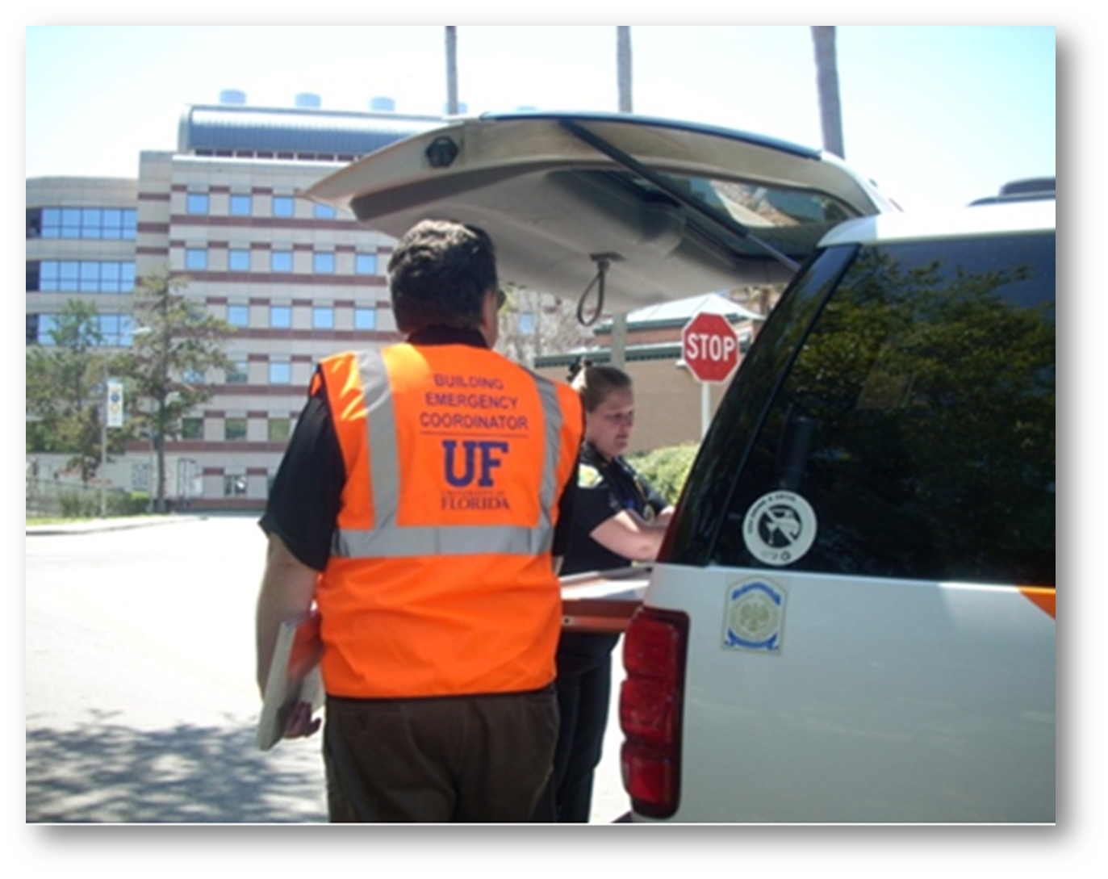
Appendix A – Emergency Guidance

This Page Left Intentionally Blank

Active Assailant
If an active assailant is reported or encountered: Run. Hide. Fight.
RUN – If the assailant's location is known and the opportunity to escape is available, flee the area.
- Have an escape plan in mind.
- If you are outside near the threat, find cover immediately!
- DO NOT pull the fire alarm to alert others.
- Keep your hands empty and visible and follow all instructions from public safety officials.
HIDE – If you are inside a building and the assailants(s) location is unknown, secure in place and deny access.
- Lock and barricade doors with heavy furniture.
- Stay away from doors or windows.
- Turn off lights.
- Block windows.
- Turn off radios and computer monitors.
- Keep yourself out of sight (take cover/protection from bullets by using concrete walls or heavy furniture).
- Silence your cell phone.
- Without jeopardizing safety, call 9-1-1 (if you cannot speak, leave the line open and allow the dispatcher to listen).
FIGHT – As a last resort and only if your life is in immediate danger, defend yourself.
- Work as a group if possible.
- Improvise weapons.
- Commit to your actions.
Source: UF Police Department (UFPD)
Resources:
UFPD - Active Assailant Video
https://youtu.be/lbbjDxiwUHo
UFPD Community Response Checklist – Active Shooter Incident
http://www.police.ufl.edu/community-services/active-shooter-response-checklist/
Training:
BEC Active Shooting Training
https://mytraining-ufshands.sumtotal.host/Core/dash/home
Version Date: August 2020

Bomb Threat
If a bomb threat is called in:
- DO NOT hang up on caller, speak calmly to them.
- Write down the incoming phone number from the caller ID.
- If another person is close by, notify them and tell them to call 9-1-1.
- Keep the caller on the line.
- Be polite and ask:
- Where is the bomb located? (building, floor, room, etc.)
- When will it go off?
- What does it look like?
- What kind of bomb is it?
- What will make it explode?
- Did you place the bomb?
- Why?
- What is your name?
- Attempt to identify characteristics of the caller and their location (age, gender, voice, background noise, etc.).
- After the call, ensure 9-1-1 was notified.
- Public safety officials will decide when and if to evacuate.
Source: UF Police Department (UFPD)
Resources:
UFPD - Bomb Threat Call Procedure/Checklist
https://police.ufl.edu/media/policeufledu/documents/brochures/Bomb-threat-procedures.pdf
Department of Homeland Security - Bomb Threat Guidance
https://www.cisa.gov/sites/default/files/publications/dhs-doj-bomb-threat-guidance-brochure-2016-508.pdf
Training:
Bomb Threat Guidelines for BECs
https://mytraining-ufshands.sumtotal.host/Core/search
Version Date: September 2018

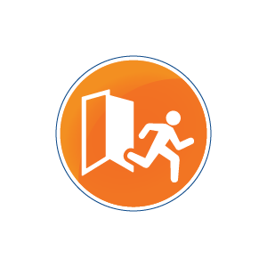
Building Fire / Evacuation
If you encounter Odor/Smoke/Fire/Explosion: RACE
- Rescue — Persons in immediate danger, if possible. This includes yourself!
- Alarm — Pull the fire alarm and call 9-1-1.
- Contain — Fire and smoke by closing doors while leaving the building (especially stairwells).
- Evacuate —
  - Take ONLY important personal items (cell phone, ID, keys, medications, wallet, purse, etc.).
  - If the corridor is filled with smoke, stay low and crawl out.
  - Do not use the elevator.
  - Exit to a safe location.
  - Move away from the building at least 100 feet.
  - Attempt to determine if all occupants in your area have evacuated.
  - Do not re-enter the building.
If building evacuation is ordered or fire alarm sounds:
- Take ONLY important personal items (cell phone, ID, keys, medications, wallet, purse, etc.).
- Do not use the elevator, if possible.
- If requested, accompany and assist persons with disabilities.
    - If special assistance is needed, call 9-1-1 and report your location and situation. Ask others as they leave the building to inform public safety officials on site of your location and situation.
- Move quickly, but in an orderly manner out of the building. DO NOT PUSH OR SHOVE.
- Once out of the building, move at least 100 feet from the structure or as instructed by public safety officials.
If confined or trapped:
- Call 9-1-1 and report your location and situation.
- Feel door. If hot, DO NOT open.
- Keep doors and windows closed to prevent the spread of fire and smoke.
- Stuff towels under the door to keep out smoke.
- Attract attention to your position if possible.
- If you have to move, stay close to the floor and crawl.
Source: UF Environmental Health & Safety (EH&S)
Resources:
EH&S - Fire Alarm/Building Evacuation Information
http://www.ehs.ufl.edu/emergencies/fire_alarm/
EH&S - Emergency Evacuation for People with Disabilities
http://www.ehs.ufl.edu/emergencies/disability_evacuation/
Training:
BEC Fire Extinguisher Training
https://mytraining-ufshands.sumtotal.host/Core/search
Version Date: September 2021

Dangerous, Disruptive, or Disturbing Employee
If you encounter a DANGEROUS employee or an employee is threatening harm to self or others:
- Call 9-1-1 immediately!
If you encounter a DISRUPTIVE or DISTURBING employee (without immediate concern for safety):
- Attempt to deescalate the situation; offer to find someone to assist in problem-solving; meet and work on a solution.
- Consult with the UFHR Employee Relations Office and notify your supervisor.
- If needed consult with the Employee Assistance Program.
- Work with your supervisor and the UFHR Employee Relations Office to develop a plan.
- Implement the plan and follow up with recommended resources and your supervisor.
- Document your actions and conversations.
If you encounter a TROUBLED employee (without immediate concern for safety):
- Consult the Employee Assistance Program and UFHR Employee Relations Office.
- Address the situation directly and how it relates to the positions; have someone else present with the two of you.
- Do not make promises of confidentiality.
- Refer employee to campus and community mental health resources.
Source: UF Human Resources (UFHR)
Resources:
UFHR - Employee Assistance Program: https://eap.ufl.edu/
(833) 306-0103 (24/7 access to a licensed counselor)
UFPD: (352) 392-1111
UFHR - Employee Relations: (352) 392-1072
Office of Victim Services: (352) 392-5648
Alachua County Crisis Center: (352) 264-6789
Version Date: September 2021

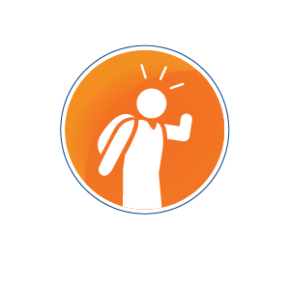
Dangerous, Disruptive, or Disturbing Student
If you encounter a DANGEROUS student or a student threatening harm to self or others:
- Call 9-1-1 immediately!
If you encounter a DISRUPTIVE or DISTURBING student (without immediate concern for safety):
- Attempt to deescalate the situation; refer the student to U Matter, We Care to assist in problem-solving; meet and work on a solution.
- Inform your supervisor.
- Consult with and notify U Matter, We Care at umatter@ufl.edu.
If your encounter a TROUBLED student (without immediate concern for safety):
- Address the situation on an individual level; consider having someone meet with you and the student.
- Consult with and notify the Dean of Students Office (umatter@ufl.edu).
- Avoid offering confidentiality to the student.
- Deal directly with the behavior according to classroom protocol; provide corrective feedback and offer to help.
- Encourage the student to use campus and community resources; offer to walk the student to assistance or call and make an appointment.
- Inform and consult with your supervisor.
Source: Dean of Students Office (DSO)
Resources:
DSO - U Matter, We Care
https://umatter.ufl.edu
DSO - Your Well-Bring
https://umatter.ufl.edu/helping-students/your-well-being/

UFPD: (352) 392-1111
DSO U Matter, We Care: (352) 294-2273
Counseling & Wellness Center: (352) 392-1575 (night and weekend crisis line for students)
DSO/Student Conduct and Conflict Resolution: (352) 392-1261
Alachua County Crisis Center: (352) 264-6789
Version Date: September 2021

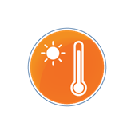
Extreme Heat
In the event of extreme heat:
- Wear lightweight, light-colored, loose-fitting warm-weather clothing.
- Avoid over-exerting yourself outdoors. Reduce, eliminate or reschedule strenuous activities until the coolest time of the day.
- Spend time in air-conditioned spaces. Consider going to a cool building if you do not have air conditioning (example – common areas, dining areas, libraries).
- Drink plenty of water to help keep your body cool and hydrated.
- Avoid excessive intake of caffeine and alcoholic beverages.
- LOOK before you LOCK – Never leave people or pets unattended in a vehicle.
Source: UF Department of Emergency Management (UFDEM)
Resources:
NWS - Heat Safety Tips and Resources
http://www.nws.noaa.gov/om/heat/index.shtml
Ready.gov - Extreme Heat
https://www.ready.gov/heat
Version Date: June 2021

Flood
In the event of flooding: Turn Around, Don’t Drown
- Avoid flooded roads, paths, sidewalks and areas, which could be damaged under the floodwaters.
- Turn around and go another way.
- Be especially cautious at night when it is harder to recognize flooding dangers.
- Notify UF Police Department (352) 392-1111 of flooding conditions.
Source: UF Department of Emergency Management (UFDEM)
Resources:
NWS – Flood Safety Tips and Resources
https://www.weather.gov/safety/flood
Ready.gov – Flood Information
https://www.ready.gov/floods
UFDEM Weather Ready – Flood
https://emergency.ufl.edu/storm-ready/weather-hazards/flood/

Version Date: August 2016

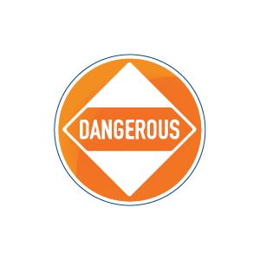
Hazardous Materials Release / Shelter-In-Place
In the event of a hazardous material release:
- Call 9-1-1.
- Do not attempt to clean up the spill unless specifically trained and outfitted to do so.
- Turn off all ignition and heat sources.
- Cover mouth with a cloth and try not to inhale gases, fumes, or smoke.
- Leave the area immediately, and keep others away.
- Stay upstream, uphill, or upwind of the release.
- Provide public safety officials with information about the spill, chemical (if known) and the spill area.
- Re-enter the building only when an “all clear” is provided by public safety officials.
If advised to shelter-in-place:
- Move inside a building immediately.
- Close and lock all windows and doors.
- Turn off A/C, if possible.
- Enter an interior room and seal the room (doors, windows, and vents) with towels, plastic, or tape for further protection, if possible.
If you are exposed to a hazardous material:
- Call 9-1-1.
- Individuals exposed to hazardous material should avoid contact with others.
- Remove all contaminated clothing, being sure not to contaminate other areas of your body.
- Flush with copious amounts of cool water for 15 minutes, ensuring that you don't scrub the chemical onto your skin.
- Exposed persons should receive or seek medical attention.
Source: UF Environmental Health & Safety (EH&S)
Resources:
EH&S - Hazardous Materials Injury/Exposure
https://www.ehs.ufl.edu/emergencies/hazardous-materials-injury-exposure/
Version Date: September 2021

Hurricanes / Tropical Weather
If the area is threatened by tropical weather:

Before the storm
- Ensure disaster supply kit https://emergency.ufl.edu/get-ready/build-a-kit/ is stocked
- Inform family and friends of plan, especially if sheltering in a different location than residence
- Refill needed prescriptions
- Fuel vehicle/generators
- Remove or secure outside items such as potted plants, grills and lawn furniture

During the storm
- Stay indoors and do not travel during the storm
- If winds become strong, stay away from doors and windows – take refuge in an interior room, closet or hallway
- Do NOT use candles, which can increase the risk of a fire
- Understand that emergency services might not be able to respond during the storm
After the storm
- Document any damage with pictures
- Take reasonable actions to protect your property from further damage
- Check on your neighbors
- Avoid downed power lines and flooded areas
- Expect delays and inconveniences
- Even campus may be damaged, so please use care when traveling around it to avoid hazards

Source: UF Department of Emergency Management (UFDEM)

Resources:
UF Hurricane Survival Guide
https://emergency.ufl.edu/wp-content/uploads/2021/11/UFDEM-Hurricane-Preparedness-Brochure.pdf

UF Disaster Supply Checklist
https://emergency.ufl.edu/wp-content/uploads/2021/08/University-of-Florida-Supply-List.pdf

Version Date: October 2021

Lightning
If you hear thunder or see lightning: When Thunder Roars, Go Indoors
- Stop all outdoor activities.
- Seek shelter in a substantial building or hard-topped vehicle.
- Avoid open high ground and isolated large trees.
- Avoid water (such as swimming pools, lakes, and rivers), beaches, and boats.
- Stay away from doors, windows, and metal objects such as pipes or faucets.
- Use the 30-30 rule for outdoor activity.
The 30-30 Rule
30 Seconds: Count the seconds between seeing lightning and hearing thunder. If this time is less than 30 seconds, lightning is still a potential threat. Seek shelter immediately.
30 Minutes: After the last lightning flash, wait 30 minutes before leaving the shelter.
If Someone is Struck by Lightning:
- Call 9-1-1. Provide directions and information about the lightning strike and victim(s).
- Give first aid. Do not delay CPR if the person is unresponsive or not breathing.
- If possible, move the victim to a safer place. Lightning can strike twice. Don’t become a victim.
Source: UF Department of Emergency Management (UFDEM)

Resources:
NWS Lightning Safety Tips and Resources
https://www.weather.gov/safety/lightning
Ready.gov – Thunderstorms and Lightning
https://www.ready.gov/thunderstorms-lightning
UFDEM Weather Ready – Lightning
https://emergency.ufl.edu/storm-ready/weather-hazards/lightning/
Version Date: August 2016

Medical Emergency – Alcohol Safety

In case of alcohol or another drug-related emergency:
- Call 9-1-1.
- Stay with the individual until public safety officials arrive.
- Do not try to give the individual anything to eat or drink.
- Be prepared to give information on the amount and type of alcohol or substance consumed.
- At UF, the student Medical Amnesty Policy protects you and your friend from conduct action. When in doubt, always call for help!
The signs or symptoms of alcohol poisoning include (not all of these need to be present):
- Confusion or stupor.
- Vomiting while passed out, not waking up after vomiting, or incoherent while vomiting.
- Seizures.
- Breathing is slow (less than 8 breaths per minute) or irregular, with 10 seconds or more between breaths.
- Weak pulse, very rapid pulse, or very slow pulse.
- Cold, clammy, pale, or very slow pulse.
- Cold, clammy, pale, or bluish skin.
- Loss of consciousness: inability to wake a person with loud shouting or inability of a person to remain awake for more than 2-3 minutes or to carry on a coherent conversation when awake (semi-conscious).
Source: UF Dean of Students Office (DSO)
Resources:
SHCC – UF Medical Amnesty Policy Information:
https://shcc.ufl.edu/about/uf-medical-amnesty-policy/
GatorWell – Alcohol & Other Drug Information:
https://gatorwell.ufsa.ufl.edu/health-topic/alcohol-and-other-drugs/

Version Date: October 2021

Medical Emergency – General

If you encounter someone experiencing a medical emergency (examples: heart attack, loss of consciousness, large loss of blood, or serious accident):
- Call 9-1-1.
- Unless trained, do not render assistance above basic first aid.
- If appropriate for the type of emergency and available, deploy AED.
  - AEDs are dispersed throughout campus and can be located on the UF Campus Map or the Gator Safe App
- DO NOT jeopardize your health and safety to render care.
- DO NOT attempt to move the injured/sick person unless they are in immediate danger.
- Have someone meet and escort public safety officials to the victim.
- Provide public safety officials with information about the incident.
Source: UF Police Department (UFPD)/Gator Emergency Medical Response Unit (GEMRU)
Resources:
EH&S – Injury/Medical Assistance
http://www.ehs.ufl.edu/emergencies/injury/
UFHR – Worker’s Compensation Information
https://hr.ufl.edu/manager-resources/employee-relations/workers-compensation/
SHCC – Emergencies and Urgent Care
https://shcc.ufl.edu/all-patients/emergencies/
EH&S – AED Procedures
https://www.ehs.ufl.edu/departments/occupational-safety-risk/risk-management-insurance-liability/risk-management/aed-procedures/
Version Date: October 2021

Medical Emergency – Seizures

If you encounter someone experiencing a seizure:
- Call 9-1-1.
- STAY with the person until they are awake and alert after the seizure.
- Keep the person SAFE; move or guide away from harm.
- Turn the person onto their SIDE if not they are not awake and aware.
  - Keep airway clear.
  - Loosen tight clothing around the neck.
  - Place a small and soft object under the head.
- DO NOT put anything in their mouth.
- DO NOT restrain.
Source: UF Police Department (UFPD)/Gator Emergency Medical Response Unit (GEMRU)
Resources:
Epilepsy Foundation - Seizure First Aid
https://www.epilepsy.com/sites/core/files/atoms/files/SFA%20Flier_HQ_8.5x11_PDF.pdf

Version Date: May 2021

Medical Emergency – Stop the Bleed

If you encounter someone bleeding profusely:
- Call 9-1-1.
- Expose wound by moving or tearing clothing away.
- Apply firm, direct pressure to the wound using gauze or a clean cloth.
- If a STOP THE BLEED kit is available:
  - Apply a tourniquet if direct pressure does not stop the bleeding.
  - Position the tourniquet at least 2-3 inches from wound and between the wound and the heart. DO NOT apply over a joint, such as elbow, knee, wrist or ankle.
  - Tighten tourniquet as much as you can.
  - Use a rod, twisting in one direction to further tighten the tourniquet and stop the bleeding.
  - Secure the rod to the tourniquet so it will not unwind.
  - Note the time that the tourniquet was applied.
Source: UF Police Department (UFPD)/Gator Emergency Medical Response Unit (GEMRU)
Resources:
Department of Homeland Security - Applying a Tourniquet
https://www.dhs.gov/sites/default/files/publications/STB_Applying_Tourniquet_08-06-2018_0.pdf

Version Date: May 2021

Suspicious Packages / Mail
If you come in contact with a suspicious packages/mail that is OPENED:
- Place it down immediately.
- If powder spills from the container DO NOT attempt to clean up.
- Leave the room and close the doors as you exit.
- Advise others to avoid the area.
- Move to a location that will minimize exposing others.
- If possible, wash hands with soap and water.
- Call 9-1-1.
If you come in contact with a suspicious packages/mail that is UNOPENED:
- Do not go near the package.
- Advise others to avoid the area.
- Call 9-1-1.
- Follow instructions from public safety officials.
Source: UF Police Department (UFPD)
Resources:
USPS - Suspicious Mail or Packages Poster
https://about.usps.com/posters/pos84.pdf
Version Date: August 2016

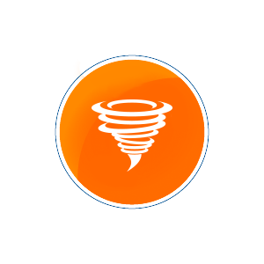
Thunderstorm Warning / Tornado Warning
If a thunderstorm warning or tornado warning is issued:
- Seek shelter in a sturdy building. Vehicles, trailers, and modular buildings may not provide good protection.
- Move to interior areas away from windows, doors, and outside walls.
- Stay indoors until the warning has expired.
- Report campus damages to the UF Police Department (352) 392-1111.
Source: UF Department of Emergency Management (UFDEM)
Resources:
NWS – Severe Thunderstorm Safety
https://www.weather.gov/safety/thunderstorm
Ready.gov – Thunderstorms and Lightning
https://www.ready.gov/thunderstorms-lightning
NWS – Tornado Safety
https://www.weather.gov/safety/tornado
Ready.gov – Tornadoes
https://www.ready.gov/tornadoes
UFDEM Weather Ready – Severe Thunderstorm
https://emergency.ufl.edu/storm-ready/weather-hazards/severe-thunderstorm/
UFDEM Weather Ready – Tornado
https://emergency.ufl.edu/storm-ready/weather-hazards/tornado/
Training:
Local Weather Hazards for BECs
https://mytraining-ufshands.sumtotal.host/core/pillarRedirect?relyingParty=LM&url=app%2Fmanagement%2FLMS_ActDetails.aspx%3FActivityId%3D824%26UserMode%3D0
Version Date: August 2016

Utility Outage / Disruption
In the event of an EMERGENCY utility outage or disruption:
- Call 9-1-1.
In the event of a POWER OUTAGE:
- If you are in an unlit area, proceed cautiously to an area that has emergency lighting.
- If instructed to evacuate, proceed cautiously to the nearest exit.
- Notify appropriate work management center.
In the event of a WATER LEAK:
- Shut down and protect critical equipment, if safe to do so.
- Notify appropriate work management center.
In the event of a NATURAL GAS smell or leak:
- Notify appropriate work management center.
- If you begin to feel ill or suspect a leak, evacuate the building/leave the area and call 9-1-1.
Source: UF Police Department (UFPD)
Resources:

Facility Services - Utility and Energy Services https://www.facilitiesservices.ufl.edu/departments/utilities/

Submit a Work Request to a Work Management Center:
- Facility Services: (352) 392-1121
https://www.facilitiesservices.ufl.edu/facility-maintenance-and-project-request/
- IFAS Facilities Operations: (352) 392-1984
http://fpo.ifas.ufl.edu/
- Housing & Residence Life: (352) 392-2161
https://www.housing.ufl.edu/iservice-requests/
Off-Campus Areas or units not served by Facilities Services, IFAS, or Housing & Residence Life should contact appropriate utility providers.
Version Date: October 2021

Winter Weather
In the event of Winter Weather with temperatures below 32° F for several hours: Follow the 5 P’s
- Protect People: Dress in warm layers and wear a hat and gloves. It is important to try to stay out of the wind and to stay dry. Also, remember to check on young children and the elderly who are the most sensitive to cold weather.
- Protect Pets: Bring outdoor pets inside or give them a warm shelter to stay in.
- Protect Plants: Cover cold-sensitive plants to protect them.
- Protect Pipes: Cover pipes and allow outdoor faucets to slowly drip to prevent freezing and breaking.
- Practice Fire Safety: Use safe heating sources indoors. Do not use fuel-burning devices such as grills; they release carbon monoxide, which is a deadly gas. Also, make sure to use space heaters according to their instructions and be attentive to open flames.
Source: UF Department of Emergency Management (UFDEM)
Resources:
NWS – Winter Safety
https://www.weather.gov/safety/winter
Ready.gov – Winter Weather
https://www.ready.gov/winter-weather
Version Date: June 2021

