Appendix C – [Department] COOP Plan

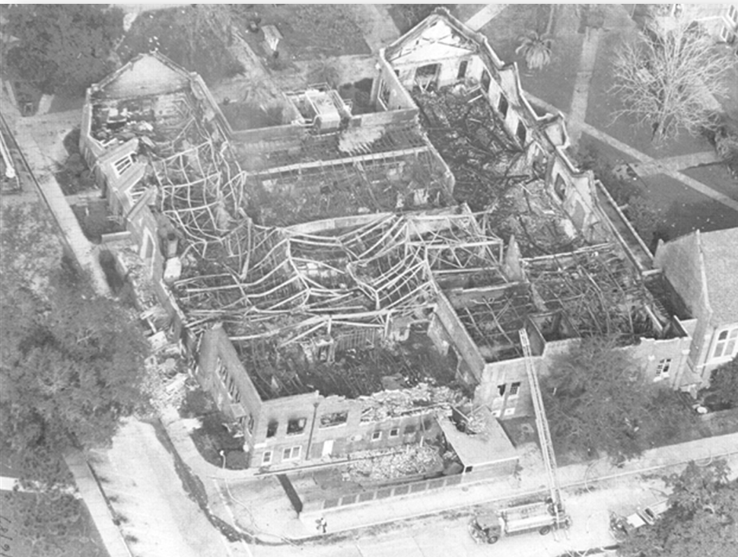

I. Introduction
A. Purpose, Scope, and Objectives
Continuity of Operations (COOP) is an effort within university units to facilitate the continued provision or restoration of mission essential functions during a wide range of potential emergencies. Florida Statutes require each state university to have a COOP plan. At UF, this responsibility is implemented through unit-level plans.

This Annex, serving as the unit’s COOP plan, identifies the mission essential functions as well as the positions, equipment, communications systems, records, and databases needed to implement those functions. Orders of succession, alternate facilities, and alternate work locations during a COOP activation are also described.

This COOP plan provides a framework for sustaining essential operations for up to 30 days after implementation. During this period, it is expected [Department] will coordinate with university administration to determine long-term arrangements necessary to restore normal operations.

B. Situation and Assumptions
The following assumptions are presupposed for planning purposes as well as for the execution of the COOP plan:
- Emergencies can cause significant injuries, illness, or deaths of employees; damages to facilities and infrastructure; and disruptions of utilities and communications.
- Emergencies, or potential emergencies, may affect the ability of [Department] to perform mission essential functions through standard operations and may require the use of alternate locations and arrangements.
- This COOP plan should be maintained at a high level of readiness, capable of implementation with and without warning.
- The plan should be operational no later than 12 hours after activation and be able to sustain essential operations for up to 30 days.

C. Authorities and References
Primary authority for the COOP plan is derived from the UF Comprehensive Emergency Management Plan (CEMP) and the emergency plan for [Department]. The legal basis for COOP operations and activities are from state authorities and guidance documents listed below.

State of Florida
- Florida Statutes Chapter 252.365
- Continuity of Operations Implementation Guidance (January 2022), Florida Division of Emergency Management

Federal
- Continuity Guidance Circular (February 2018), Federal Emergency Management Agency

[Department]
- [Insert list of applicable departmental authorities/references]
- [Example – Departmental IT restoration plan]

II. Mission Essential Functions
Mission essential functions are those which must be continued to provide vital services, maintain the safety and well-being of university students, faculty, staff, and visitors, and sustain critical university operations. Functions not deemed mission essential
al can be deferred until additional personnel and resources become available.

Mission essential functions should be restored on a prioritized basis.
- Priority 1: Functions that need to be restored within one day.
- Priority 2: Functions that can be restored later than one day but within seven days.
- Priority 3: Functions that can be restored later than seven days but before thirty days.

The table below provides an overview of identified mission essential functions and associated priority levels for [Department].

Mission Essential Function | Priority | Restoration Timeframe
[Insert from Part 1 of Section X tables] | 1 | 1 Day
[Expand table as needed] | 2 | 2-7 Days
 | 2 | 2-7 Days
 | 3 | 8-30 Days
 | 3 | 8-30 Days

III. Delegations of Authority and Orders of Succession
If the [VP/Dean, Director, or Department Chair (DDD)] is unavailable or unable to perform responsibilities as the senior leader of [Deparmtent], the following list will be employed for the succession of leadership, providing for rapid response to an emergency requiring activation of the COOP plan. Cessation of the delegation will occur when the [VP/DDD] is available and can assume duties, or an acting or interim [VP/DDD] is appointed by the university. The [VP/DDD] may supersede this list by specifically delegating authority ahead of planned absences.

Succession of [VP/DDD] by Position
1 | [Example - Associate DDD for…]
2 | [Example - Associate DDD for…]
3 | [example - Assistant DDD]

Personnel other than [identify departmental positions] do not have financial or budgetary authority. [Insert other applicable limitations on authority.]

IV. Alternate Work Locations
A. Alternate Facility
An emergency may leave [Department’s current facility] inaccessible or inoperable, necessitating relocation of some employees to an alternate site to maintain or restore mission essential functions. Based on the equipment, resources, and space for the number of employees outlined in this plan, the following location has been identified to function as an alternate site.

Alternate Facility(s) | Location

An alternate facility may be identified from other departmental locations or external sources such as another department. The facility selected should have sufficient space and equipment to maintain designated employees and be capable of sustaining operations for up to 30 days.

For locations controlled by another department, attach a letter of agreement authorizing the use of the facility during COOP activations.

The alternate site should have an appropriate level of operational, cyber, physical, and access controls, in line with university controls and primary facility. Detail any specific security or access measures in place for the alternate facility.

B. Alternate Work Location (Telework)
Remote work allows employees to perform mission essential functions off-site to maintain departmental functions. This approach can be employed as a preliminary measure while relocating to the alternate site, to augment office space for supporting functions, or as a stand-alone solution when appropriate.

Use of alternate work locations should follow guidance from Human Resources and the university’s Alternate Work Location Policy: https://hub.policy.ufl.edu/s/article/Alternate-Work-Location.

[Insert details on department alternate work location plans.]

V. Logistics Support and Resource Requirements
The following positions will support a COOP activation by implementing this plan and completing actions necessary to maintain or restore assigned mission essential functions.

Position | # Of Positions Needed | COOP Role and Responsibility
[Insert from Part 2 of Section X tables]
[Expand table as needed]

Identified personnel should maintain drive-away kits to support assigned mission essential functions. Kits should include any necessary equipment not pre-positioned at the alternate location. [Insert details on kits, including needed components such as office supplies, telephones, and contact lists.]

The table below outlines equipment which will need to be relocated to or available at the alternate site.

Equipment | Notes
[Insert from Part 2 of Section X tables]
[Expand table as needed]

VI. Interoperable Communications
The following communications systems, either software and/or hardware, are necessary to maintain or restore designated mission essential functions. Access to these systems is needed at the alternate facility and alternate work locations.

Guidance on helpful technology tools and resources for working remotely and how to access them is available from UF Information Technology: https://it.ufl.edu/community/remote-work-resources/.

Information on and access to UF’s cloud-based services is offered at https://cloud.it.ufl.edu/.

Communications Software/Hardware | Location | Function/Description
[Insert from Part 3 of Section X tables]
[Expand table as needed]

VII. Vital Records and Databases
The following vital records and databases, both physical and electronic, are necessary to maintain or restore designated essential functions. These vital records and databases are protected and accessible through the locations indicated below.

[Insert details on departmental storage of vital records for access during COOP activation, such as the use of UFIT GatorCloud services for remote access and protection.]

Vital Record/Database | Location(s) | Type | Function/Description
[Insert from Part 4 of Section X tables]
[Expand table as needed]

VIII. COOP Evaluation and Activation
Following an incident or emergency which impacts [Department] the [VP/DDD] will determine the effects on the organization’s facilities and operations. Based upon the evaluation, the [VP/DDD] will execute all or portions of the COOP plan as necessary to maintain or restore identified mission essential functions. An implementation may include evacuation, relocation, and/or alternate work locations depending on the nature and specifics of the situation.

Evacuation
A no-notice incident may trigger a COOP event due to an extended building evacuation. Follow procedures identified in Section II.F of the Basic Plan. Employees should be notified promptly if relocation and/or alternate work locations are required to continue essential operations. Reference notification process in Section VI.A.2 of Basic Plan.

Relocation to Alternate Facility
If the [primary facility] cannot be occupied due to damage, loss of utilities, or other reasons, activation of the [alternate facility] may be justified to continue identified mission essential functions.

Alternate Work Location (Telework)
When appropriate, and communication/IT infrastructure is functional, employees may be directed to work remotely to continue identified mission essential functions. This approach can be utilized instead of or to augment activation of the alternate facility.

- Phase 1 – Activation
Notify employees of activation of COOP plan, providing information on operations of the alternate facility and/or alternate work locations. Detail expected actions of all employees for both duty and non-duty hours. Transition operations of identified mission essential functions to the alternate facility and/or alternate work locations.

- Phase II – Alternate Operations
Perform identified mission essential functions critical to university and [Departmental] operations using details in essential function tables and this plan. Evaluate staffing needs and alternate methods, adjusting as needed. Begin preparations for a return to normal operations and primary facility. Engage [appropriate senior university leadership for the department] if alternate operations will be necessary beyond 30 days to plan for long-term operations and a new primary facility, if required.

[Insert details on specific university leadership, internal or external customers, and other stakeholders that should be notified of the transition to alternate operations.]

- Phase III – Reconstitution and Termination
When the threat or emergency conditions no longer exist, return to normal operations and primary location as appropriate. Inform all employees of the transition and provide instructions for the resumption of normal operations. When deactivated, return and restock equipment and supplies from the alternate to the primary facility, including drive-away kits.

IX. Tests, Training, Exercises, and Program Maintenance
An exercise of the COOP plan should be conducted [annually] by [Department]. The exercise should include an evaluation of the alternate facility operations, vital records and databases accessibility, communications functionality, as well as inventorying of COOP equipment and supplies. Needed updates and areas for improvement revealed during the exercise will be noted and adjusted in the plan as appropriate to validate readiness and capabilities.

Identified positions tasked with roles and responsibilities in this document, as well as [Department] leadership, should receive [annual] training on the COOP plan to review procedures and be prepared to execute.

Additionally, the following online COOP training courses are available from FEMA:
- IS-1300, Introduction to Continuity of Operations
This course is intended to lay the foundation of knowledge for students who wish to increase their understanding of continuity and building a comprehensive continuity program in their organization
- IS-545, Reconstitution Planning Course
As the final phase of continuity, reconstitution is an integral part of your organization’s continuity plan. This course addresses each part of a reconstitution plan and explores best practices to implement your plan.
- IS-120.C, An Introduction to Exercises
This course introduces the basics of emergency management exercises. It also builds a foundation for subsequent exercise courses, which provide the specifics of the Homeland Security Exercise and Evaluation Program (HSEEP).

Funding resources needed to address capability gaps or ongoing maintenance should be included within the [Department] strategic budget requests and enhancements

X. Mission Essential Functions Tables
The following pages contain a table for each identified mission essential function in prioritized order. These tables summarize the information included in the document and individually can serve as a quick reference guide for employees activating or exercising the function.

Use these forms to conduct a business process analysis of your department’s mission essential functions. To complete:

Step 1
- Brainstorm and list all mission essential functions.
- Prioritize compiled list of functions into three tiers for restoration.
  - Priority 1’s: Functions that need to be restored within one day.
  - Priority 2’s: Functions that can be restored later than one day but within seven days.
  - Priority 3’s: Functions that can be restored later than seven days but before thirty days.
- Keep in mind that your department will have numerous important functions, but this plan is not intended to sustain all departmental operations. Narrow focus to mission essential functions. Mission essential functions are those which must be continued to provide vital services, maintain the safety and well-being of university students, faculty, staff, and visitors, and sustain critical university operations. These are the functions of your department that cannot be delayed for more than 30 days or less.
Step 2
- Complete a table in this section for each identified mission essential function on the list.
- Once completed, use the tables to populate the corresponding sections of the COOP plan.

[Duplicate tables as needed for each mission essential function identified.]

Priority 1 – (Insert Mission Essential Function Name)
- Mission Essential Function
Function |  |  | Priority Level | Steps to complete Essential Function
- Insert Step
- Insert Step
- Logistics Support and Resource Requirements
Position(s) needed to conduct function |  |  | # of Positions Required | Skills Needed
Equipment needed to conduct function |  |  | Notes
- Interoperable Communications
Communications Software/Hardware needed to conduct function |  | Location |  |  |  | Function/Description
- Vital Records and Databases
Vital Record/Database needed to conduct function | Location |  |  |  | Type |  | Function/Description
- Alternate Continuity Strategy
List potential strategies and implementation steps for alternatives (examples – mutual aid, vendor support, others) to address the function if unable to executive COOP plan.
Alternate strategy |  |  |  | Implementation steps

Priority 2 – (Insert Mission Essential Function Name)

- Mission Essential Function
Function |  |  | Priority Level | Steps to complete Essential Function
- Insert Step
- Insert Step
- Logistics Support and Resource Requirements
Position(s) needed to conduct function |  |  | # of Positions Required | Skills Needed
Equipment needed to conduct function |  |  | Notes
- Interoperable Communications
Communications Software/Hardware needed to conduct function |  | Location |  |  |  | Function/Description
- Vital Records and Databases
Vital Record/Database needed to conduct function | Location |  |  |  | Type |  | Function/Description
- Alternate Continuity Strategy
List potential strategies and implementation steps for alternatives (examples – mutual aid, vendor support, others) to address the function if unable to executive COOP plan.
Alternate strategy |  |  |  | Implementation steps

Priority 3 – (Insert Mission Essential Function Name)

- Mission Essential Function
Function |  |  | Priority Level | Steps to complete Essential Function
- Insert Step
- Insert Step
- Logistics Support and Resource Requirements
Position(s) needed to conduct function |  |  | # of Positions Required | Skills Needed
Equipment needed to conduct function |  |  | Notes
- Interoperable Communications
Communications Software/Hardware needed to conduct function |  | Location |  |  |  | Function/Description
- Vital Records and Databases
Vital Record/Database needed to conduct function | Location |  |  |  | Type |  | Function/Description
- Alternate Continuity Strategy
List potential strategies and implementation steps for alternatives (examples – mutual aid, vendor support, others) to address the function if unable to executive COOP plan.
Alternate strategy |  |  |  | Implementation steps

